
PROJECT REPORT

COURSE REGISTRATION SYSTEM

Database Management Systems Lab

Submitted By:

Naveed Ahmad(22pwcse2165)

Jamal khan(22pwcse2203)

Omer khan(22pwcse2130)

Section B

Submitted to:

Mam Sumayyea Salahudin

Date: 04/07/2025

Department of Computer Systems Engineering

University of engineering and technology, Peshawar

Introduction
The Course Registration System is a web-based platform that enables students to register for courses, instructors to manage their teaching schedules, and administrators to oversee academic data.

Objectives
- Build a digital alternative to manual course registration
- Enable real-time enrollment
- Facilitate instructor and admin access to course data
- Provide a responsive user interface

Tools & Technologies
- Backend: Laravel 11, MySQL
- Frontend: React.js, Axios
- Hosting: Netlify (frontend), Hostinger (backend)

System Overview
- Users: Student, Instructor, Admin
- Features: Authentication, Course Enrollment, Admin Panel, RESTful API integration

Backend Development
- Laravel Models: Student, Instructor, Course, Enrollment, Department
- RESTful APIs using api.php
- Eloquent relationships and middleware
- Tested using Postman

Entity Relationship Diagram (ERD)
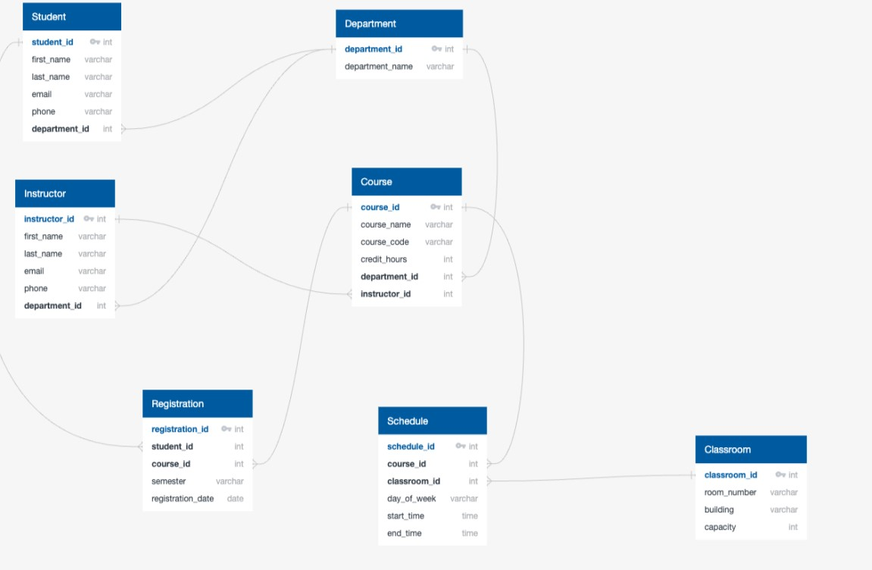

Frontend Development
- Built using React
- Pages: Home, Login, Dashboard, Course Registration
- Axios for API requests

Hosting & Deployment
- Frontend hosted on Netlify
- Backend hosted on Hostinger
- .env setup and CORS configured

Challenges Faced
- CORS handling
- Hosting Laravel on Hostinger
- State management in React
- Many-to-many data handling in Laravel

Conclusion
This project demonstrates how modern web technologies can be used to streamline academic systems, offering scalability and efficiency.

References
- https://laravel.com/docs
- https://react.dev
- https://docs.netlify.com
- https://support.hostinger.com
- https://chat.openai.com

screenshot:


